**LAB 2: UI Design Process (Task Flow & User Flow Diagram)**

**1. Enter Your Name and Register Number:**

|  |
| --- |
| **SHALU KUMARI (1947259)** |

**2. Enter the Domain & Application Chosen:**

|  |
| --- |
| **E-Commerce Application & Flipkart** |

**3. Describe the Problem Identified (5 Lines)**

|  |  |
| --- | --- |
| **Problem Identified** | **Proposed Solution (Task 1 & Task 2)** |
| The problem in flipkart is there is no button or any kind of option available for searching a particular product via image, with this feature, searching will be easy and effective. | * They can add that feature on search button so that people can search products based on its image * They can make a separate button to search based on image |

**4. One Proposed Task Flow Diagram**

*Task flows concentrate on how users navigate across the application when executing a given task. They usually represent only one direction and don’t have several branches or paths as a typical user flow would.*

***General Template: Entry Page -> Action / Task -> Exit Page / Success***

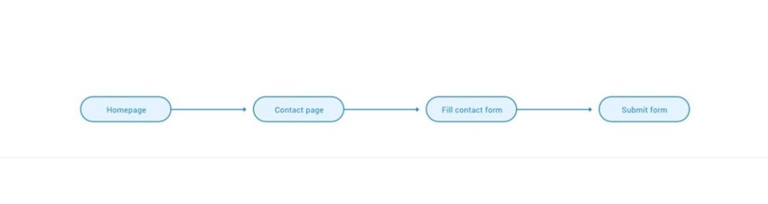

***Sample 1: Task flow for searching a product through an image in flipkart***

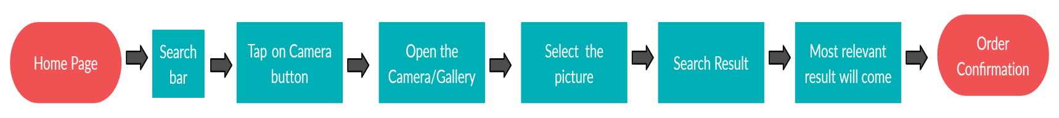

***Sample 2:***

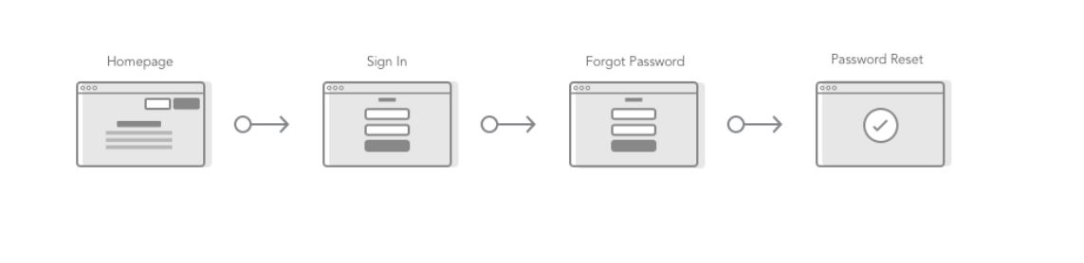

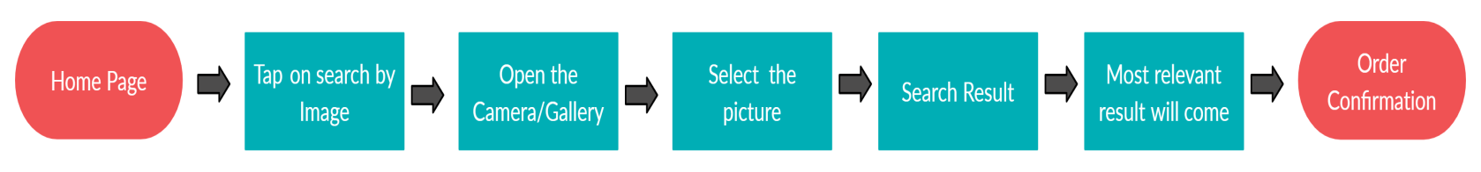

**5. One Proposed User Flow Diagram**

*The User flow diagram illustrates the full direction taken by a user when a feature is used. It also describes the movement of the user through the application, figuring out each and every step taken by the user from the entry point to the final stage. Here, flows are made out of individual interactions.*

***General Template: $\frac{What the User Sees}{What the User Does}=> \frac{What the User See Next}{What the User Do Next}$***

***The following symbols can be used:***

*1. Rectangle: To display a task*

*2. Diamond: To display the decision*

*3. Circle: To display an action*

***Sample 1:***

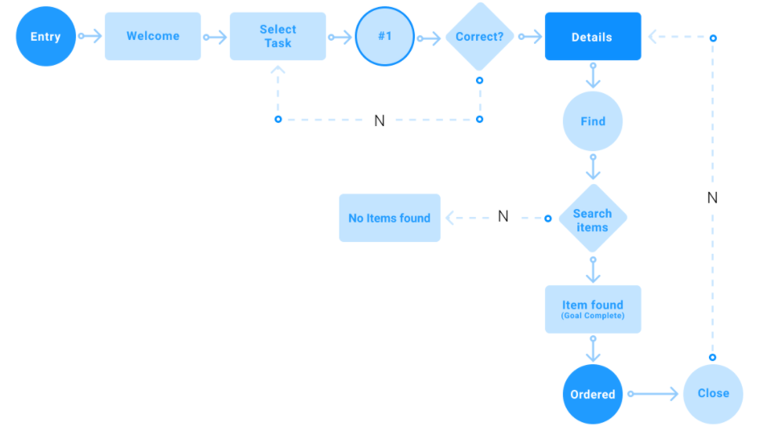

***Sample 2:***

